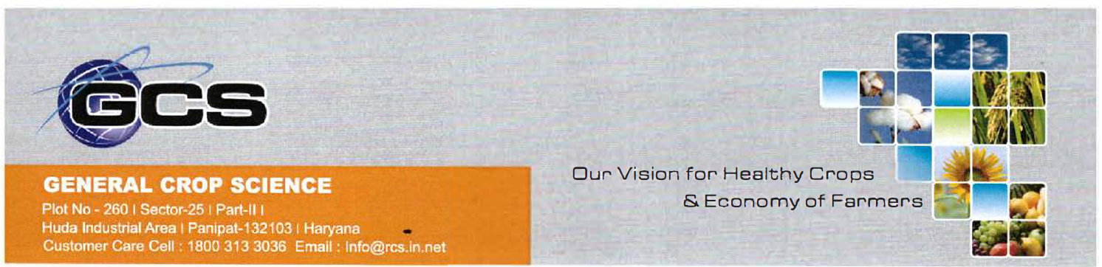

INFORMATION ABOUT VERIFIED GROSS MASS OF CONTAINER
Sr. No. | Details of Information | Particulars
1* | Booking no.
2* | Name of the shipper | GENERAL CROP SCIENCE
3* | Shipper Registration/License No. (IEC No/CIN No) ** | 3317502126
4* | Name and designation of official of the shipper authorised to sign document | MR. VISHAL GULATI
5* | 24 x 7 contact details of authorised official of shipper | 9996025642
6* | Container No.
7* | Container Size (TEU/FEU/other)
8* | Maximum permissible weight of container as per the CSC plate
9* | Verified gross mass of container (method-1/method-2) | CARGO WEIGHT:  TARE WEIGHT:  VGM WEIGHT :
10* | Date and time of weighing
11* | Weighing slip no.
12* | Weighbridge registration no. & Address of Weighbridge | IND/09/2003/681 DICT SONEPAT
13* | Type (Normal/Reefer/Hazardous/others) | HAZARDOUS
14* | If Hazardous, UN No, IMDG class | UN Number: 3017  IMDG Class: 6.1

For GENERAL CROP SCIENCE

Authorised Signatory
DT.


